BRACT’s
Vishwakarma Institute of Technology, Pune
Practical Implementation Sheet
Department: CSE-AI Semester: 5 Academic Year: 2026-27
Division: E Batch: 2 Practical No: 3
Roll no: 37 PRN No: 12412175 Name of Student: Rugved Raut
Subject Name : Deep Learning

Problem Statement
Implement Forward Propagation and Backpropagation using TensorFlow/Keras. Analyze the effect of different learning rates and the number of epochs on model performance.
Algorithm
- Start the program.
- Import the required libraries: TensorFlow, Keras, Matplotlib.
- Load the MNIST handwritten digit dataset using mnist.load_data().
- Normalize the training and testing images by dividing pixel values by 255.
- Create a Sequential Neural Network model.
- Add a Flatten layer to convert 28×28 images into a 1D vector.
- Add a hidden Dense layer with 128 neurons using ReLU activation.
- Add an output Dense layer with 10 neurons using Softmax activation.
- Compile the model using the Adam optimizer with a learning rate of 0.001 and Sparse Categorical Crossentropy loss function.
- Train the model for 5 epochs using the training dataset.
- Plot the training and validation accuracy graph.
- Plot the training and validation loss graph.
- Evaluate the trained model using the testing dataset.
- Display the testing loss and testing accuracy.
- Train the model using different learning rates (0.1, 0.01, 0.001, 0.0001) and compare the accuracies.
- Train the model using different epochs (1, 5, 10, 20) and compare the accuracies.
- Analyze the effect of learning rates and epochs on model performance.
- Stop the program.
Code
Google Colab:
https://colab.research.google.com/drive/1lMhoWXA0EeZv6tajqXZuEv2sMHdg9zUr?usp=sharing
Output
Training Accuracy Graph and Training Loss Graph
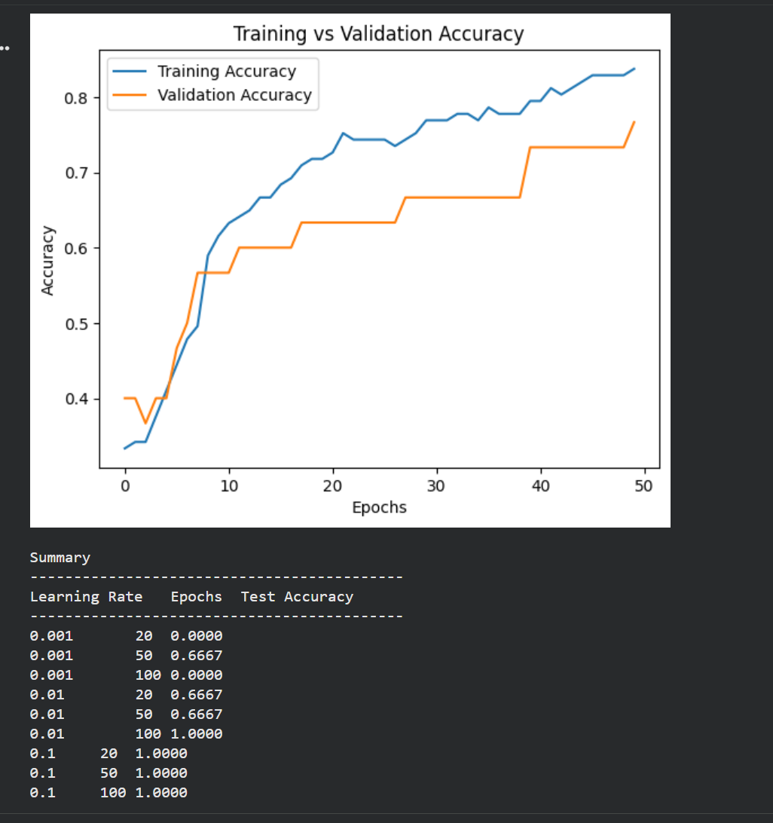

Backpropogation:
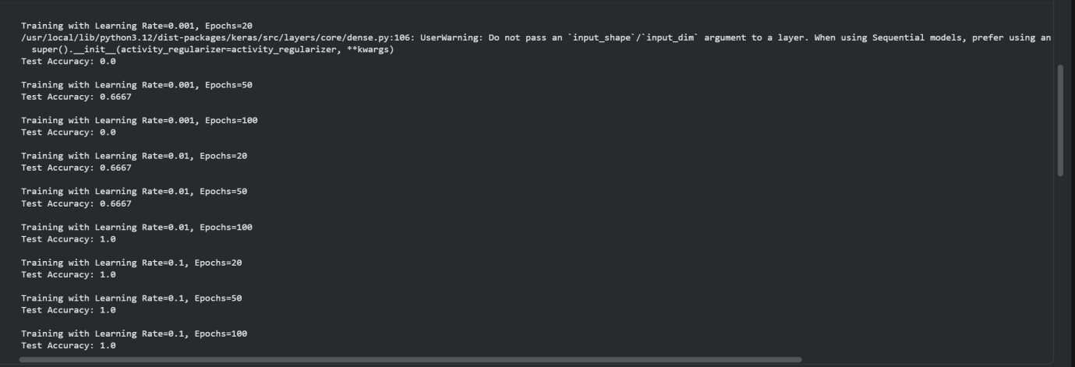
Example:
Test Loss : 0.0785
Test Accuracy : 97.85%

